1. Design a Data Warehouse for IPL Cricket Tournament (Asked in Flipkart Interview for Senior Data Engineer role)

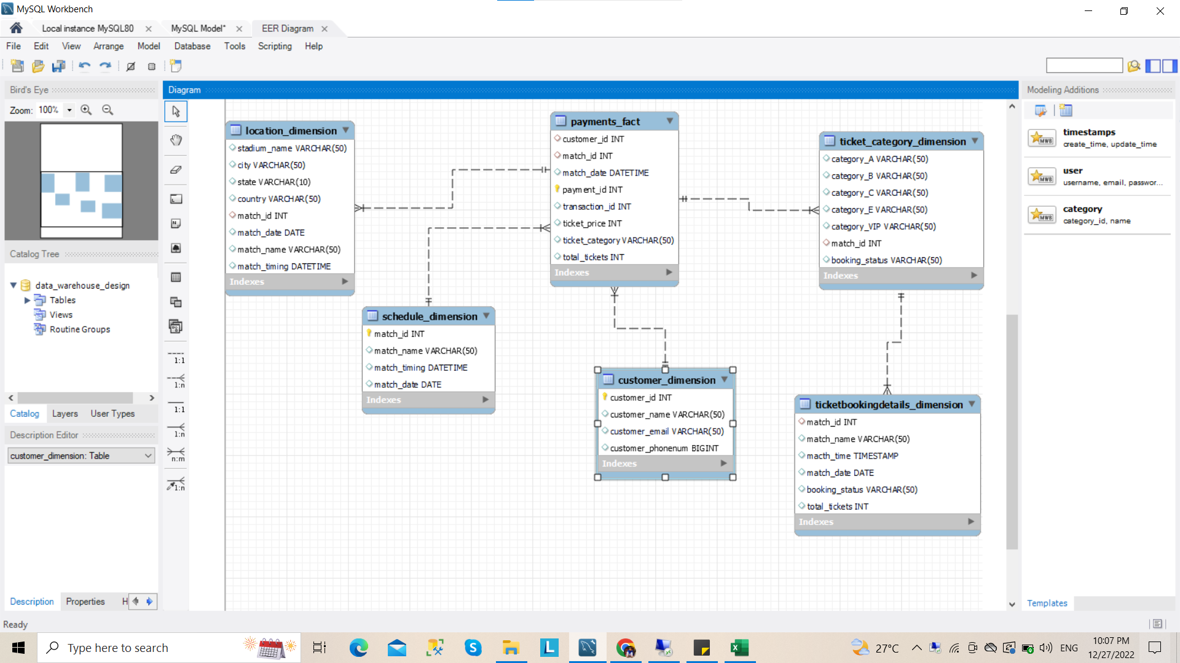

1. Design a Data Warehouse for Food delivery app like Swiggy, Zomato (Asked in Grab for Data Engineer role)

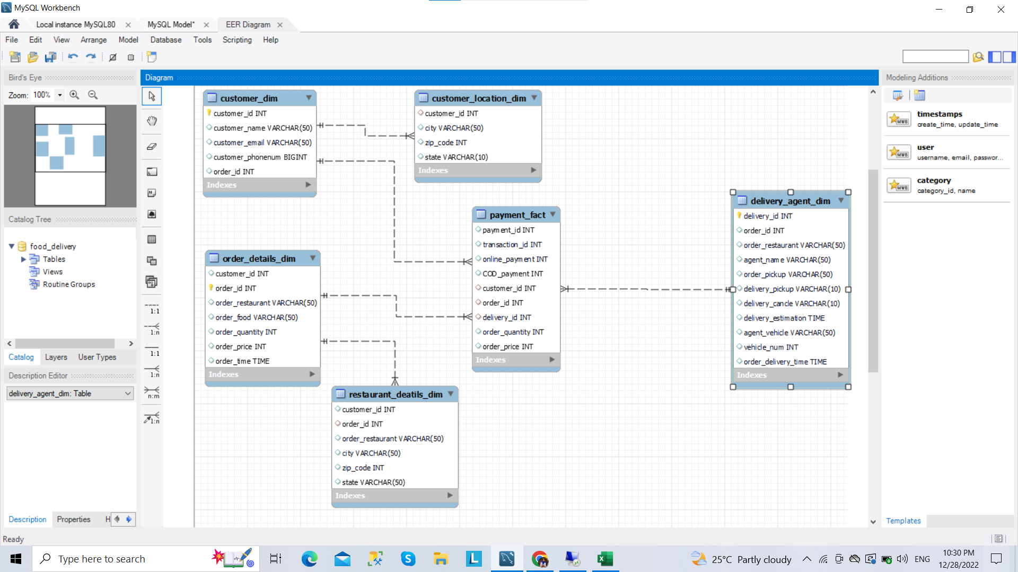

1. Design a Data Warehouse for cab ride service like Uber, Lyft (Asked in Google for Data Engineer role)

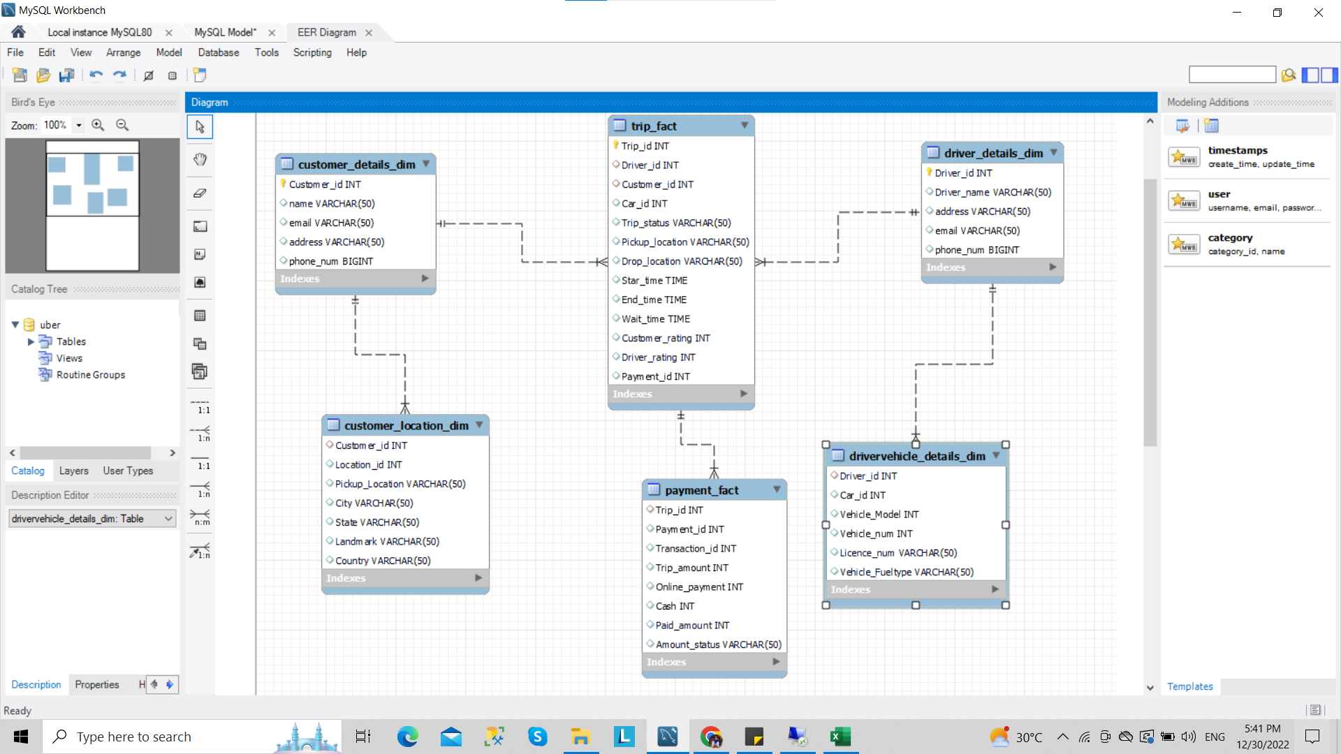

1. Design a Data Warehouse for Restaurant table booking app like Dine out (Asked in McKinsey for Consultant Data Engineer role)

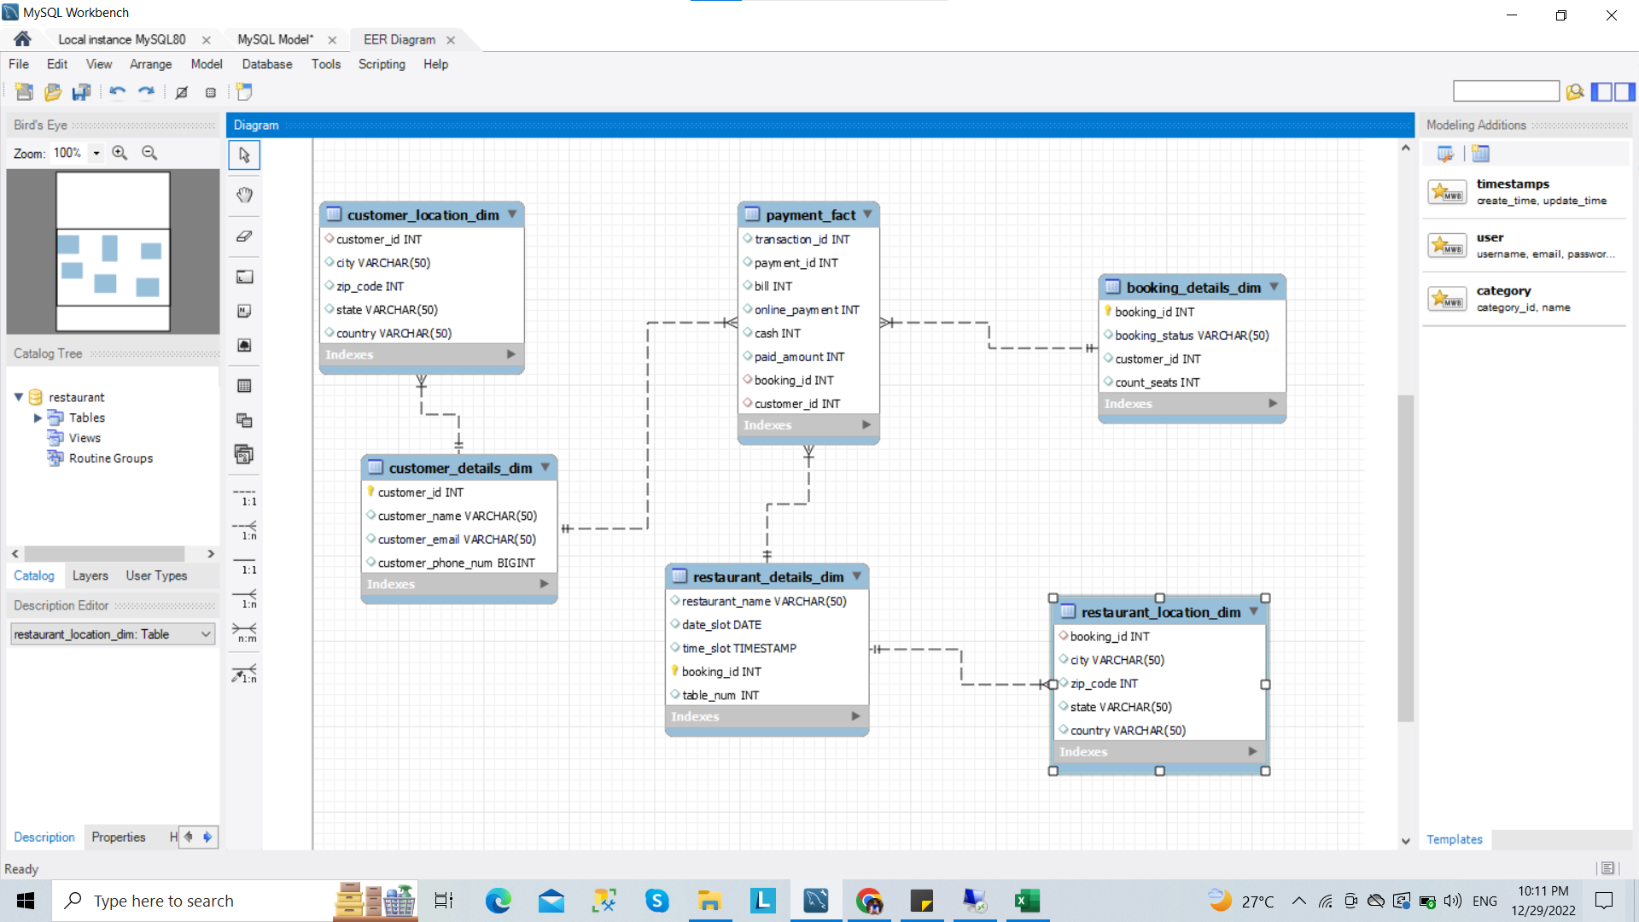

1. Design a Data Warehouse for Covid Vaccination Application (Asked in Livsapce for Data Engineer role)

